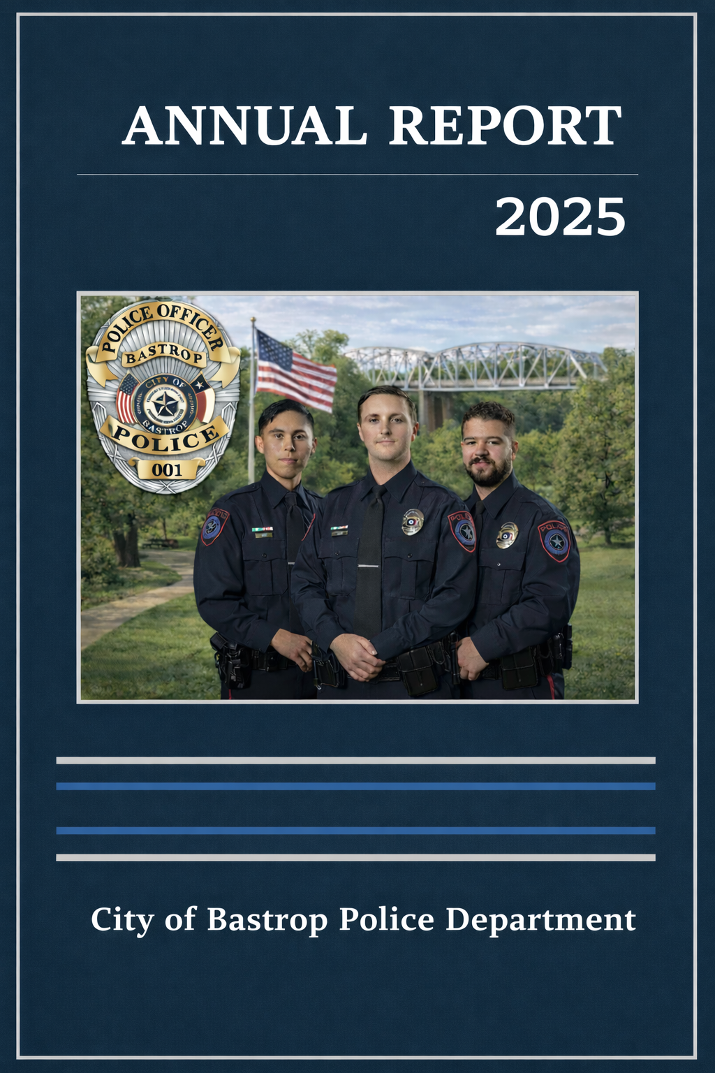


The Office of the Chief of Police
Vicky Steffanic

vsteffanic@cityofbastrop.org

YEAR IN REVIEW 2025

Message from the Chief



It is imperative that we promote the organizing principle of accountability within our organization. This standard must be incorporated into our mission and vision statements and integrated into our daily culture of expectations. To make certain we are maintaining and continuing to strengthen the public’s trust in the City of Bastrop Police Department, we must adhere to and follow a progressive discipline model. The importance of this is to promote that accountability and provide an employee the opportunity to reflect, learn and grow in this profession.

This report strives to ensure we provide transparency to our community, by communicating our activities. In addition, we are able to examine our own data respective to customer service, training, and enhancing our professionalism.

City of Bastrop Police Department
Professional Standards Division
104 Grady Tuck Lane
Bastrop, Texas 78602
512-332-8600
BPDCommunity@cityofbastrop.org

City of Bastrop Police Department

MISSION Statement

The Mission of the City of Bastrop Police Department is to effectively and efficiently provide for the protection of lives and property, preserve the public peace, and provide needed community services with the highest level of professionalism and ethical standards.

VISION Statement

As a professional, trusted, and respected Department, in collaboration with our community, we strive to provide Bastrop with the utmost in public safety while serving with honor.

Guiding Principles

Integrity: The Bastrop Police Department is built upon a foundation of ethical and professional conduct. We are committed to the highest level of moral principles and ethics. All members of the Department will adhere to the Law Enforcement Code of Ethics which is a part of this manual.

Honesty: We will be truthful and trustworthy at all times.

Fairness: We are committed to equal application of the law to offenders and members of the public as well as the equal application of rules and regulations to all members of the Department.

Courage: We are dedicated to meeting all challenges with the courage needed to accomplish our mission.

Compassion: We understand our role as community caretakers and temper our application of the law with compassion and empathy.

SUMMARY

As we continue our commitment to serving the Bastrop community with professionalism and integrity, this report highlights many of the activities and efforts our department undertook over the past year. While it is not intended to provide formal analysis, it offers a clear and straightforward presentation of data to help our residents better understand the work being done on their behalf. We are proud to share this information as part of our ongoing commitment to transparency and community partnership.

AGENCY INFORMATION

* This information is as of 02.16.2026 and may have been slightly different during the past year due to hiring. Sworn officers are listed in graph A, non-sworn (cadets and civilians) are listed in graph B.

GRAPH A
Race/ Ethnicity
Female
Male
misc
Black
0
0
Hispanic
4
6
1 reserve officer
White
5
12
2 or more
0
2
GRAPH B
Black
0
2
Hispanic
1
1
White
5
3
2 or more
0
0
Asian
0
1
TOTAL counts:
Sworn personnel
29
includes reserve officer
Cadets
7
Civilians
6
Total Organization
42

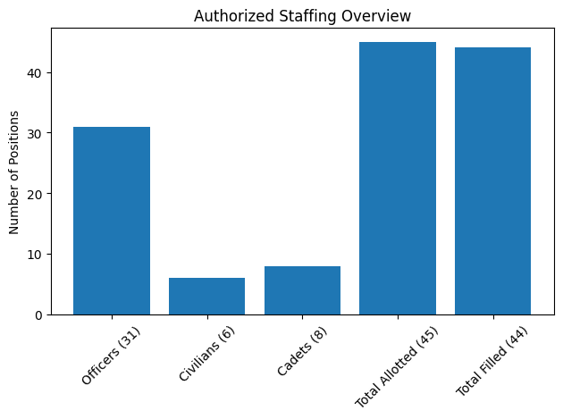 Vacant position is a cadet position.
* Reserve officers are not line-item positions.

PROFESSIONAL STANDARDS

Over the past year, our department established a Professional Standards unit to further strengthen our commitment to excellence and accountability. This division plays an important role in advancing our accreditation efforts while ensuring we maintain objective and professional oversight within our organization. It also helps us identify and address training needs, apply discipline in a consistent and fair manner, and enhance transparency for the community we serve. Through this initiative, we continue working to build trust and uphold the high standards our residents expect and deserve.

What are Professional Standards?

The Professional Standards unit is responsible for maintaining the highest level of professional conduct within our department. This division oversees Internal Affairs, responses to resistance, progressive officer discipline, mentorship and training, and accreditation efforts. The officer leading this division works closely with and reports directly to the Chief of Police to ensure accountability at the highest level.

This unit manages the intake and review of both compliments and complaints from the public. Complaints are carefully evaluated and categorized based on their nature and seriousness, with clearly established procedures guiding how each type is handled.

When a complaint involves significant deviations from behavioral expectations established through formal training, departmental policies, rules, or regulations, an Internal Affairs investigation may be recommended to the Chief of Police. These investigations are highly regulated, thoroughly documented, and conducted with objectivity and professionalism.

Other concerns may be classified as general complaints. These typically involve minor deviations from policy or procedural expectations. After an initial review, the matter may be escalated if necessary or addressed at the supervisory level through training, corrective action, or other appropriate measures.

Through this structured and transparent process, the Professional Standards unit ensures fairness, accountability, and continued professional development within our department.

In addition to overseeing Internal Investigations, our Best Practices Unit is diligently working toward achieving accreditation.

What is accreditation?

Law enforcement accreditation is a voluntary process in which police agencies adopt and maintain standardized policies and procedures that meet recognized professional standards. In Texas, the Best Practices Accreditation Program includes 170 standards developed by experienced Texas law enforcement professionals. These standards are designed to promote efficient and effective service delivery, reduce organizational risk, and safeguard individual rights.

Accreditation helps ensure that agencies operate in a manner that is consistent, fair, and constitutionally sound. A committee of professional police chiefs from across Texas develops, reviews, and approves these standards. This same committee conducts the final review of an agency’s compliance efforts and awards “Accredited” status once all requirements are met.

To achieve and maintain accreditation, agencies must demonstrate compliance with all established standards and undergo regular reviews. This includes continuous evaluation and updates to policies and procedures to ensure they remain aligned with current laws, best practices, and community expectations.
By adopting these best practices, agencies enhance operational efficiency, improve officer safety, and reduce legal risk. Most importantly, accreditation reinforces a culture of accountability and transparency. Through this process, we are strengthening our commitment to protecting individual rights and building trust and confidence within the Bastrop community.

Accreditation is a voluntary commitment to excellence.

The Texas Best Practices Accreditation Program establishes 170 professional standards developed by experienced Texas law enforcement leaders. These standards help ensure agencies operate efficiently, effectively, and in alignment with constitutional and statutory requirements.

To become accredited, a police department must:

- Adopt and follow all required professional standards
- Demonstrate compliance through documentation and review
- Undergo evaluation by a committee of Texas police chiefs
- Participate in ongoing reviews to maintain accredited status

Why it matters:

- Improve delivery service
- Enhances officer safety
- Reduces organizational risk
- Protects individual rights
- Promotes accountability and transparency

Accreditation reflects a department’s commitment to professionalism, continuous improvement, and public trust.

COMPLIMENTS / COMPLAINTS

In 2025 the listed Compliments / Complaints were received by our department.

Above are the numbers of what was received and the outcome by one of four designated categories.

Of the four outcome designated categories, the above shows the outcome of each complaint.

RESPONSE TO RESISTANCE

A Response to Resistance refers to any incident in which an officer uses force during an interaction. These situations require officers to rely on their training, experience, sound judgment, and skill to determine the appropriate level of force necessary to safely accomplish a lawful objective. Officers are trained to use only the level of force that is reasonable, necessary, and consistent with department policy.

Every Response to Resistance incident is carefully reviewed. In addition to oversight by a patrol supervisor, each case is also reviewed by the Professional Standards Division to ensure compliance with policy, proper application of training, and accountability. This layered review process helps ensure transparency, reinforce high professional standards, and supports continuous improvement within the department.

In 2025 our department had approximately 33,002 interactions with the public.

ACCIDENTS / INJURIES

There are a variety of accidents that can occur in our work environment. Whether it is a personnel injury, vehicle accident, or injury while at work. Below is a summary analysis of injuries and accidents at the police department for 2025. Injuries listed ‘on-duty’ do not correspond with the vehicle crashes listed below.

 | Amount | # who missed hours | total hours missed | total cost for repairs
Injuries on Duty | 12 | 1 | 8 out  66 hours of light duty | NA
Vehicle Crashes | 12 | 0 | 0 | $14,731.53

YEARLY STATISTICAL DATA

Patrol

Criminal Investigations

Records

CONTINUOUS GOALS FOR OUR DEPARTMENT

Organizational Development and Career Pathways

The department implemented a hybrid Criminal Investigations position designed to provide junior officers with investigative experience while supporting patrol operations. We strengthened adherence to best practices, formalized mentorship programs, and developed alternative career pathways to promote recruitment, retention, and internal professional growth. These efforts are helping create clear opportunities for advancement and long-term success within the organization.

Operational Capacity and Community Demand
As our city continues to grow, so does the demand for police services. Despite staffing and workload challenges, the department has taken a proactive approach by increasing traffic enforcement, expanding patrol activity, and submitting more cases for prosecution. At the same time, we have maintained strong participation in community engagement initiatives to ensure we remain visible, accessible, and responsive to residents.
To sustain this level of service and meet future demand, the department is planning not only to increase the number of sworn personnel, but also to add critical civilian support staff positions. Expanding both sworn and civilian roles will allow officers to remain focused on public safety responsibilities while strengthening overall operational efficiency.

Technology and Equipment Modernization
The department continues to modernize its technology and equipment to better serve the community. Significant progress has been made in standardizing equipment and implementing advanced tools, including Cellebrite forensic data extraction technology, state-compliant surveillance initiatives, and drone technology. Additional improvements are planned as we continue strengthening our operational capabilities.

Training and Professional Development
Substantial advancements have been made in training and professional development. All patrol personnel are current on policy and best practice requirements, with clearly defined pathways for career advancement. All Criminal Investigations Division personnel are now certified TCOLE instructors, and several officers have obtained specialized instructor certifications. The department has also begun hosting training programs that benefit internal staff, other city employees, and neighboring agencies—further demonstrating our commitment to regional collaboration and professional excellence.

For any further information please feel free to contact me anytime!

Respectfully Submitted:

VS

Chief of Police
Vicky Steffanic
City of Bastrop Police Department

